**1. Assignment**

**Background:** I ama system administrator responsible for managing the IT infrastructure of a medium-sized company. The company is expanding its online presence and needs a reliable DNS server to manage internal and external domain name resolution. You've decided to implement this on Red Hat Enterprise Linux due to its stability, security features, and robust support.

**Steps Involved:**

1. **Server setup**

Provision a new server with Red Hat Enterprise Linux installed .

iscpu : display information about the CPU

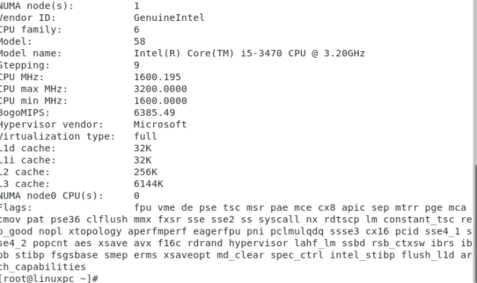

free –h : check available and used RAM

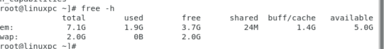

df –h : see the disk usage on your system

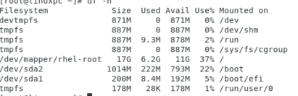

**2.Installation of DNS Software:**

BIND (Berkeley Internet Name Domain), the most widely used DNS software on Linux systems

**Install bind :** yum install bind* -y

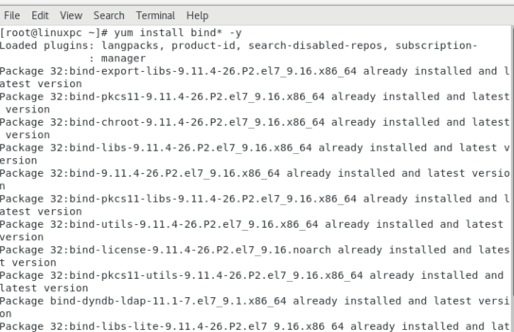

Rpm –qa | grep bind : list all installed packages on the system

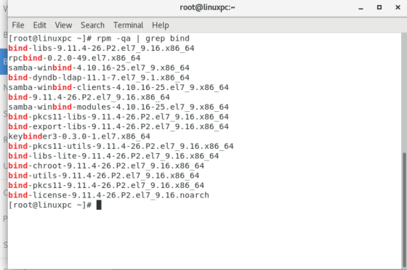

**3.Configuring BIND:** Edit the BIND configuration files

**Cp /etc/named.conf /etc/named.conf.orginal** : This command makes a copy of the /etc/named.conf file (which is the main configuration file for the BIND DNS server) and stores the



**cp /etc/named.rfc1912.zones /etc/named.rfc1912.zones.original:** This command creates a backup of the /etc/named.rfc1912.zones file (which contains default zone configurations recommended by RFC 1912) and saves it as /etc/named.rfc1912.zones.original



vi /etc/named.conf: The command vi /etc/named.conf is used to open the **BIND configuration file** (named.conf) in the **vi** text editor on Linux systems

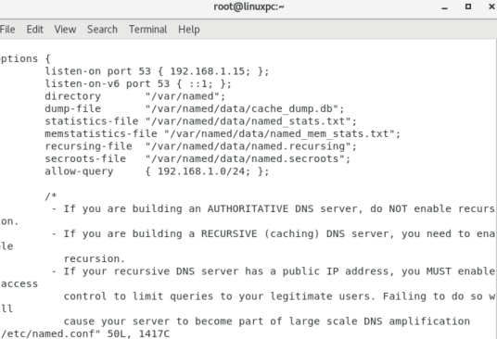

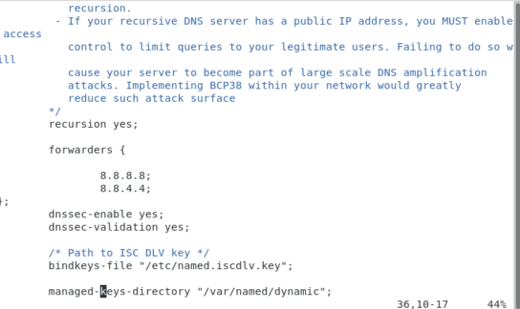

**vi /etc/named.rfc1912.zones:** The command vi /etc/named.rfc1912.zones is used to open the file /etc/named.rfc1912.zones using the **vi** text editor in Linux

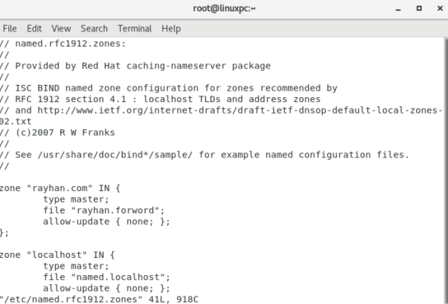

**4.Creating DNS Zones:**

Define and configure DNS zones:

**Cd named:** This command attempts to change the current working directory to a directory named named

**CP named localhost rayhan.forword:** It looks like you're trying to copy or rename DNS zone files using the cp (copy) command. Based on the commands you’ve mentioned, I likely want to create backups or rename the configuration files.

**Cp named looback rayhan.reverse**: It seems like you want to use the cp command to copy a file related to "loopback" to a new file called rayhan.reverse. The syntax you are using is missing a few necessary elements, like specifying the full path to the source and destination files. 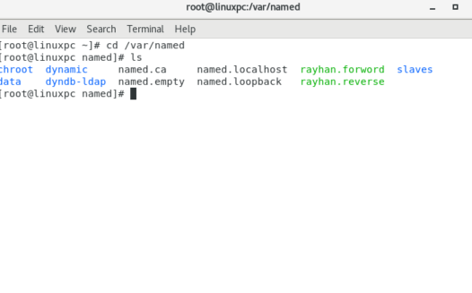

.

**Forward Lookup Zones:**Create zones to map domain names to IP addresses (A records), mail exchange (MX records), aliases (CNAME records),

**Vim rayhan.forword:** This file is used to define **hostname-to-IP mappings** for the domain. An **A (Address) record** maps a **domain name** to an **IPv4 address**. It's one of the most fundamental types of DNS records. 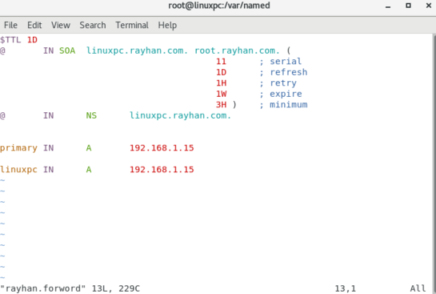

**Reverse Lookup Zones:**Set up zones to map IP addresses to domain names (PTR records), which are particularly useful for reverse DNS lookups

**Vim rayhan.reverse** : A **reverse lookup zone** is a special type of DNS zone used to map an IP address back to its associated domain name.

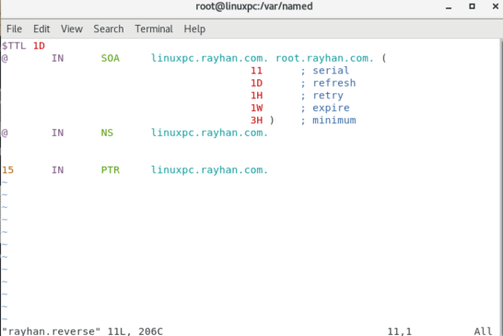

**Securing the DNS Server:**

Implement security measures such as restricting zone transfers, configuring access controls and enabling DNSSEC (DNS Security Extensions) to provide data integrity and authentication

Solution ;

* Cd /var/named:

dnssec-keygen -a RSASHA256 -b 2048 -n ZONE rayhan.com:

• -a RSASHA256: Specifies the algorithm (RSASHA256 is recommended and widely supported).

• -b 2048: Specifies the key size (2048 bits for the ZSK is common).

• -n ZONE: Indicates the key is for a DNS zone.

• rayhan.com: The zone name.

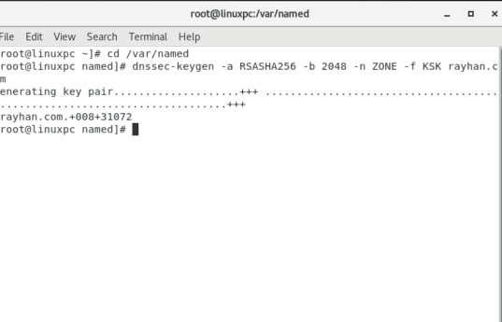

dnssec-keygen -f KSK -a RSASHA256 -b 4096 -n ZONE rayhan.com:

* -f KSK: Specifies that this is a Key Signing Key (used to sign other DNSSEC keys).
* -a RSASHA256: Uses the RSASHA256 algorithm (recommended).
* -b 4096: Key size in bits (4096 is common for KSKs).
* -n ZONE: Declares this key is for a DNS zone.
* rayhan.com: Your zone name.

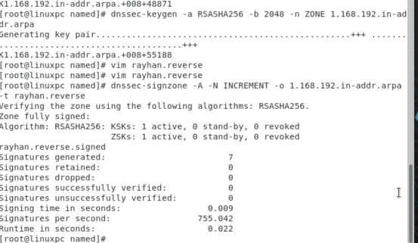

**Vim /named/rayhan.forword:**

Here's how to **properly use** the Krayhan.com.+008+<keyid>.key and files in your DNSSEC configuration process

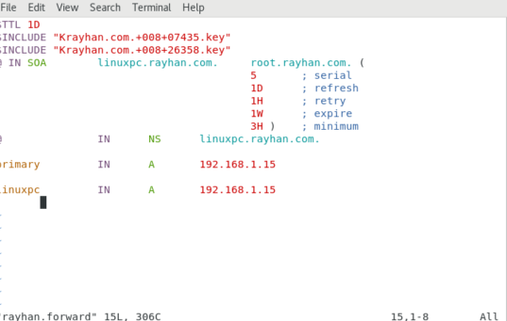

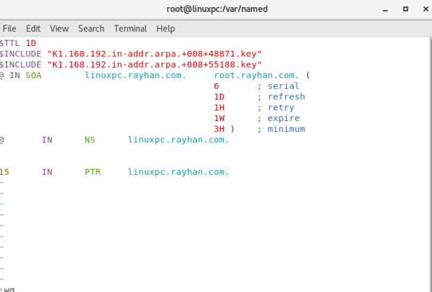**Vim/named/rayhan.reverse:**configure this file

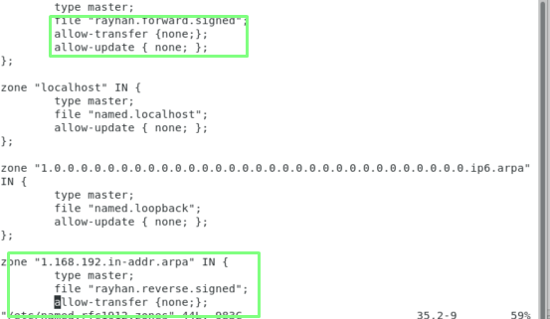

**rayhan.com.zone.signed:**

**I have a signed zone file — rayhan.com.zone.signed. This file is the output of the dnssec-signzone**

**command and contains your original zone data plus all the DNSSEC records (like RRSIG, DNSKEY, and** NSEC/NSEC3 records

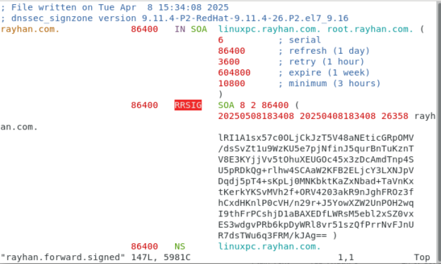

**6.Testing and Validation and :**

Test the DNS server teasting

**te**

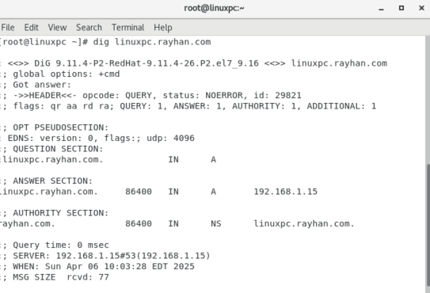**8.Testing and validation :** configuration using tools like dig(domain information groper) to ensure proper resolution of domain names both internally and externally.

**9.Monitoring and Logging:**

Set up logging b to monitor DNS queries, errors, and server activity

Add logging section in named.conf file

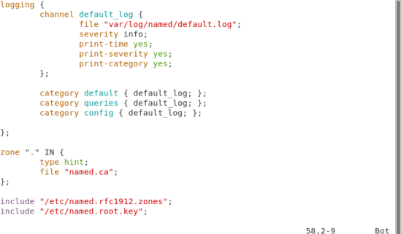

**Tailvar/log/messages :** This command will display the last few lines of the /var/log/messages log file and continuously update the output as new lines are added to the file. It's useful for monitoring system logs, especially for debugging or tracking server activity

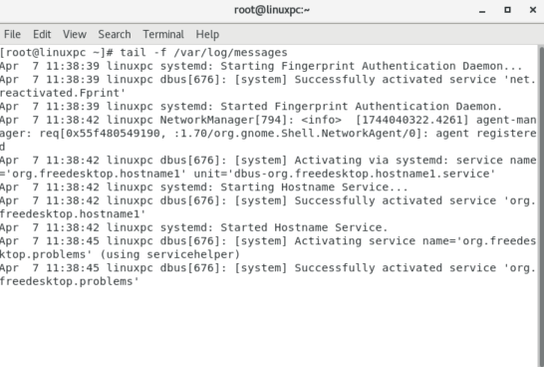 **Cat/var/log/messages:** The cat /var/log/messages command will display the contents of the /var/log/messages file in its entirety, which typically includes general system logs, kernel logs, and logs from various system services.

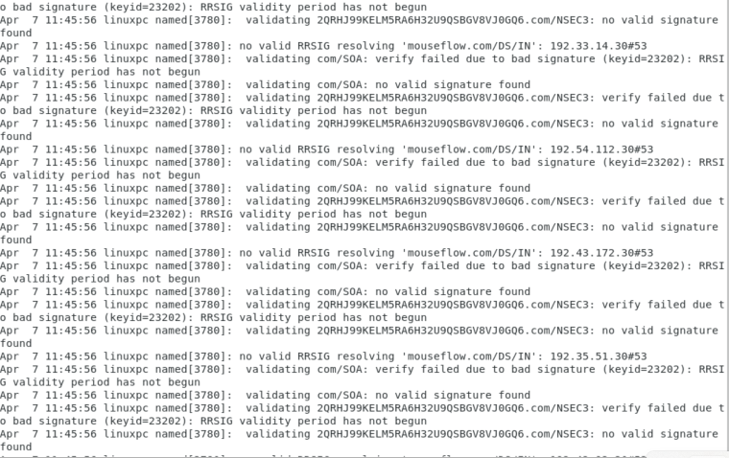

.Configure monitoring tools like Nagios  to receive alerts and notifications about DNS server performance and health

**sudo yum install -y gcc glibc glibc-common make unzip httpd php gd gd-devel per**l: inatall Nagios tools this command

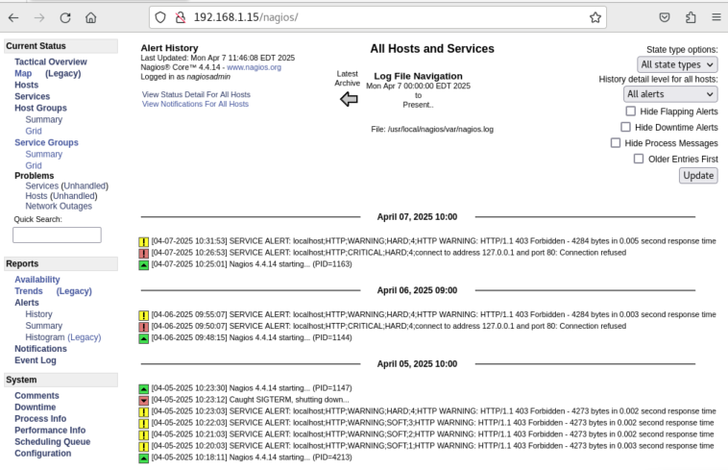**wget https://github.com/NagiosEnterprises/nagioscore/releases/download/4.4.14/nagios-4.4.14.tar.gz: Download Nagios Core:** Go to the Nagios website to get the latest version or use wget to download it directly.

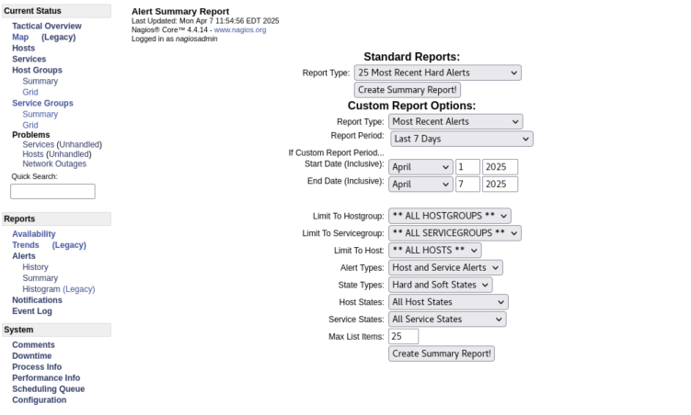**9.Backup and Disaster Recovery:**

Implement a backup strategy to regularly back up BIND configuration files (named.conf zone files)

* Cp /etc/named.conf /tmp: **cp**: The command to copy files.
* **/etc/named.conf**: The source file (the configuration file for BIND).
* **/tmp**: The destination directory, in this case, the temporary directory.

This will copy the named.conf file to /tmp so you can make modifications, backup, or review it without affecting the original file.

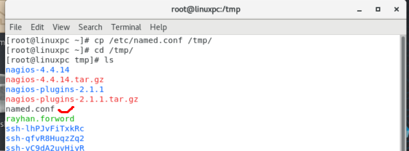

DNS databases (/var/named/) to ensure quick recovery in case of server failures or data loss

**Scp named.conf root@192.168.1.75**:

• **scp**: The command used for securely copying files between systems over SSH.

• **named.conf**: The source file you want to copy (make sure it's in the current directory or provide the full path to it, e.g., /etc/named.conf).

• **root@192.168.1.75:/tmp**: The destination on the remote server. Here, root is the user, 192.168.1.75 is the IP address of the remote server, and /tmp is the target directory on the remote server.

.

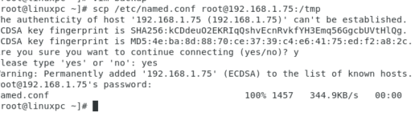

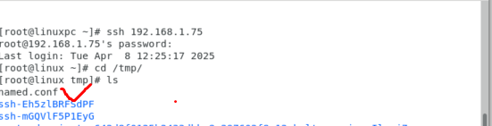

**conclusion:** setting up a secure, reliable DNS server with BIND on RHEL involves proper configuration, testing, integration, and monitoring to ensure efficient name resolution and network stability.